Instalamos Docker en Linux

sudo apt update
sudo apt upgrade

sudo apt install -y ca-certificates curl gnupg

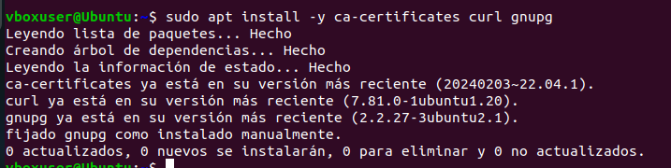

# Agregar la clave oficial de Docker
sudo install -m 0755 -d /etc/apt/keyrings
curl -fsSL https://download.docker.com/linux/ubuntu/gpg | sudo tee /etc/apt/keyrings/docker.asc > /dev/null
sudo chmod a+r /etc/apt/keyrings/docker.asc

# Agregar el repositorio de Docker
echo "deb [arch=$(dpkg --print-architecture) signed-by=/etc/apt/keyrings/docker.asc] https://download.docker.com/linux/ubuntu $(lsb_release -cs) stable" | sudo tee /etc/apt/sources.list.d/docker.list > /dev/null

sudo apt update
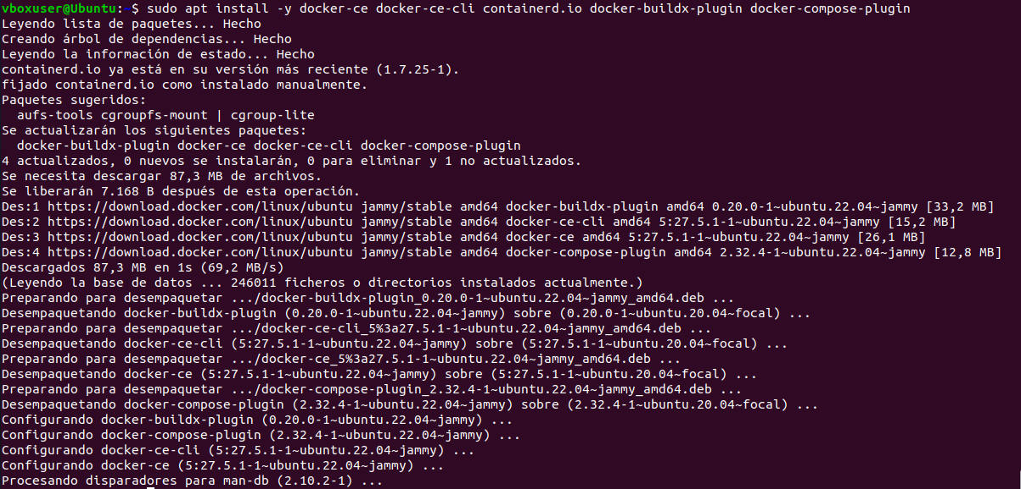
sudo apt install -y docker-ce docker-ce-cli containerd.io docker-buildx-plugin docker-compose-plugin
docker --version

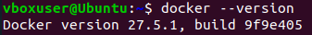

Para usar Docker sin sudo, agrega tu usuario al grupo docker:
sudo usermod -aG docker $USER
newgrp docker
